**From:** Bernadette Parrillo [mailto:bparrillo@ripcpc.com]   
**Sent:** Friday, June 12, 2020 2:56 PM  
**To:** Susanne Campbell <scampbell@ctc-ri.org>  
**Cc:** Candice Brown <cbrown@ctc-ri.org>  
**Subject:** Questions from CTC re: Virtual PCMH Patient Satisfaction Surveys using Constant Contact

[WARNING] This email originated outside of our organization, please USE CAUTION when clicking on links or attachments.

Hello Susanne,

It was nice to see and talk to you again earlier this week.  I have some answers to the questions you asked about our new process for satisfying the PCMH patient experience requirements, using *Constant Contact* to conduct avirtual survey.

**Question:  “Approximately” what percentage of a RIPCPC practice’s patient panel has e-mail addresses on file?**

**Answer:**  That will vary, based on the practice, since it’s up to the practice staff to collect that information.  Some may be better about it than others, so there’s no uniform answer, unfortunately.  But, for the several surveys that we’ve already sent out, each practice has had a sufficient amount of email addresses to send to.  Smaller practices naturally have fewer than larger practices.  So far, of the surveys that we’ve already sent out, 291 was the lowest number of email addresses that a practice had on file (which still isn’t bad for purposes of the survey!), and that was a practice of approximately 850 patients. But again, it will vary by practice.   Many of our practices are located in relatively suburban areas, so they probably have a higher percentage of patients with e-mail addresses on record than do practices that are located in the cities.

**Question:  How does the application provide the surveys in different languages?**

**Answer:**We created the survey form as a *Microsoft Word* document, composed of 10 questions that satisfy NCQA’s required categories of access, communication, coordination, and whole person care / self management support (see attached sample).  The survey itself is not conducted through *Constant Contact*.  *Constant Contact* is simply the application that we use to send the mass email to all patients.  In the *Constant Contact* email we include the link to the practice’s survey form, which is actually created through a survey site that our IT department has given our project manager access to (Microsoft Forms, forms.office.com).  Some places use Survey Monkey, so a survey form could be created there as well.  In order to allow patients to access the survey in different languages,  we would have to translate the survey into the required language, add it as an option, and then the patient would select which language to use (at least, that’s how it appears that it would work). We’ve never created one yet with a second language, but it looks like that would be the process.   Since we just started using this virtual survey process for our surveys, we haven’t expanded its use to different languages yet, but we have future plans to do so.

**Question:  How does the data look within *Constant Contact*?**

**Answer:** Here is a portion of some recent results from one of our practices.As you can see in Question #1, When you hover over any portion of the bar graph, a pop-up message appears, containing the percentage of responses for that category.  The bar graphs provide a quick visual representation of the responses, so if we were looking for the question with the lowest rate of “extremely satisfied” responses, it appears that we would select either question #3 or question #10 as a target for improvement in this example.  (Hovering over the dark orange portions of the graphs for those 2 questions would give you the exact numerical percentage rate of “extremely satisfied” responses.)

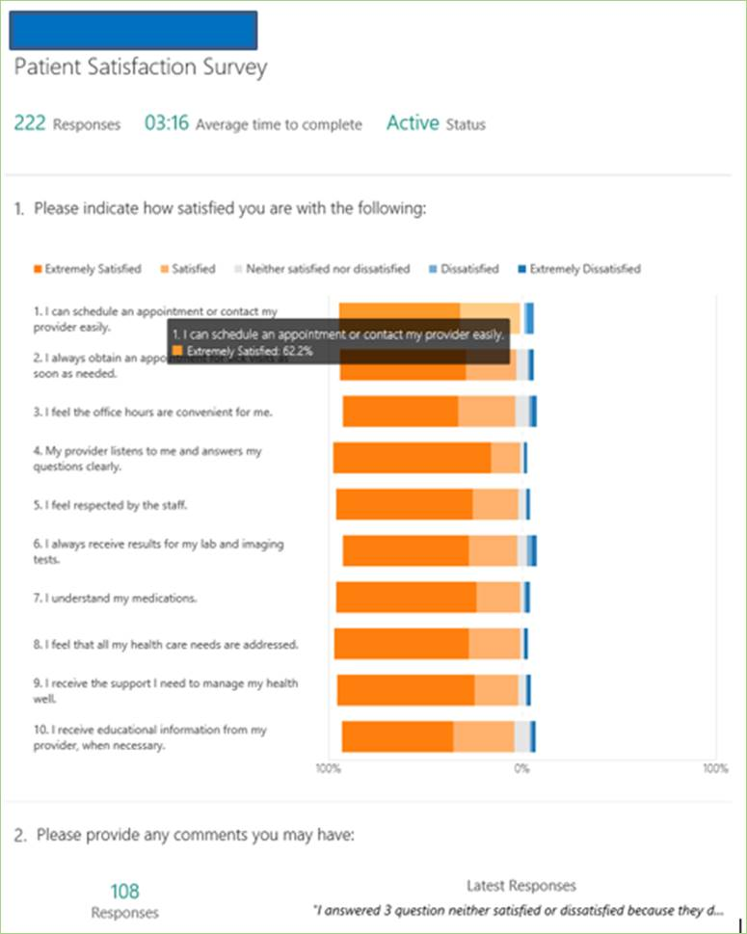

**Question:  How do the exported results appear?**

**Answer:**  I attached an Excel spreadsheet containing the results of the “test” practice that was sent out to the QIS Team to complete when we started this process.  *However, keep in mind – the results are exported from the survey site we use and have nothing to do with Constant Contact.  If CTC wants to use Microsoft Forms, then this is how the exported results will look.*

**Question:  How much does it cost to use?**

**Answer:** That depends on how many “contacts” you have in *Constant Contact*.  So every time we add an excel file with email addresses, it adds more contacts, however, it can be deleted once those contacts are not needed anymore.  Below is a screenshot of the pricing plan, and as you can see,  5,001 – 10,000 contacts are currently selected.  If  you have more or less,  then the price goes up or down.



I hope this information is helpful.  Have a nice weekend!

-Bernadette

|  |  |  |  |  |  |  |  |  |  |  |  |  |  |  |  |  |  |  |  |  |  |  |  |  |  |
| --- | --- | --- | --- | --- | --- | --- | --- | --- | --- | --- | --- | --- | --- | --- | --- | --- | --- | --- | --- | --- | --- | --- | --- | --- | --- |
| |  |  |  |  |  |  |  |  |  |  |  |  |  |  |  |  |  |  |  |  |  |  |  |  |  | | --- | --- | --- | --- | --- | --- | --- | --- | --- | --- | --- | --- | --- | --- | --- | --- | --- | --- | --- | --- | --- | --- | --- | --- | --- | | |  |  |  |  |  |  |  |  |  |  |  |  | | --- | --- | --- | --- | --- | --- | --- | --- | --- | --- | --- | --- | | |  |  |  |  | | --- | --- | --- | --- | | |  | | --- | | **Bernadette Parrillo​** | | Quality Improvement Specialist | | RI Primary Care Physicians Corp | | | |  |  |  |  | | --- | --- | --- | --- | | |  | | --- | | Office: (401) 654‑4000 x119 | | Fax: (401) 654‑4001 | |  | |  |  | | | | |  |  |  |  |  |  |  |  |  |  |  | | --- | --- | --- | --- | --- | --- | --- | --- | --- | --- | --- | | |  |  |  | | --- | --- | --- | | |  |  | | --- | --- | | |  | | --- | | [RI Primary Care](http://www.ripcpc.com/) | | | | |  |  |  |  |  |  | | --- | --- | --- | --- | --- | --- | | |  |  |  |  |  | | --- | --- | --- | --- | --- | | |  |  |  |  | | --- | --- | --- | --- | | |  |  |  | | --- | --- | --- | | |  | | --- | | cid:image002.png@01D63FE8.DB56CDF0 | | [Integra](http://www.integracare.org/) | | | | | | | |