KIDSNET Second Lead Screening Report

Step 1
Select the Age Ranges and “Generate Report”

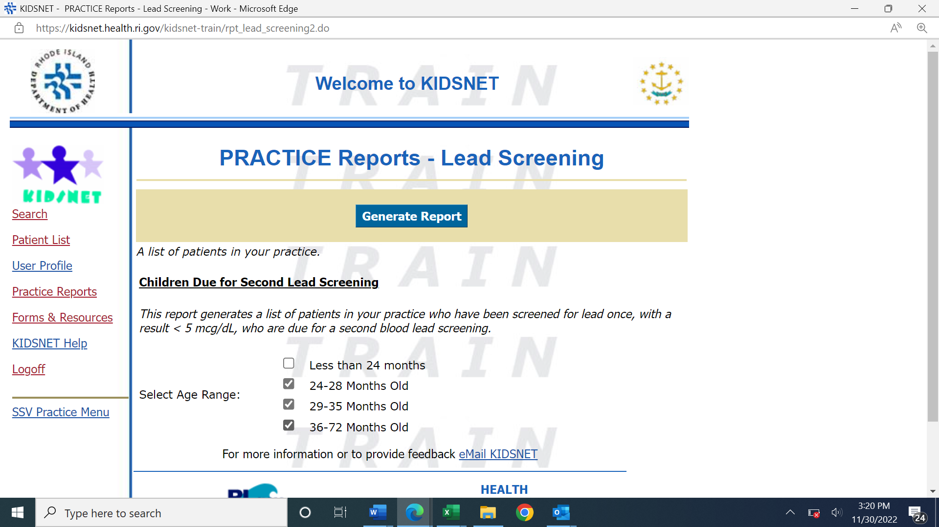

Step 2
Download Report

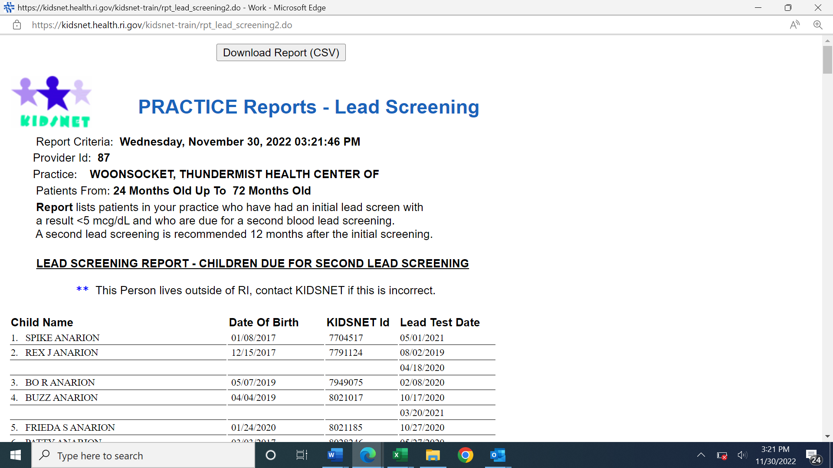

Highlight Excel report, (upper left corner of spread sheet)
Click on DATA (Tool Bar)
Click on Sort (Tool Bar)
Select Column C (date of birth)
Identify children in the desired date of birth range, example – (11/1/2018 – 10/31/2019)

