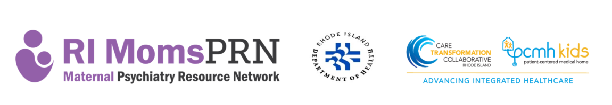
RIDOH and CTC-RI are pleased to provide practices who participate in the RI MomsPRN Program an opportunity to earn additional practice payments of up to $1,500 for the collection and reporting of supplemental data/counts with required quarterly screening reports. Practices who opt to provide the demographic factors listed below will be eligible to receive $1,500 of extra practice payments. These payments will be split into two and paid at the contract midpoint and the contract close. For any demographic variables deemed hard to collect, RIDOH and CTC are willing to accommodate longer implementation timeframes and have follow-up discussions regarding feasibility. Data would begin to be reported and included with quarterly screening reports, starting with the report due on November 18, 2022. As mentioned previously, some reporting flexibility may be offered for select variables. This agreement indicating practice data intentions is due to be signed no later than September 16, 2022.

[Insert practice name and/or site] will provide the following additional data with their required quarterly screening reports (check all that apply):
☐ De-Identified perinatal patient demographic data for $1,500 of additional practice payments. Please check any variables that may be “hard” to collect/report at this point in time and may need a longer timeline for implementation.
☐ Age

☐ Race

☐ Ethnicity

☐ Health plan/insurance type

☐ Pregnancy status at time of screen or data run

☐ [Insert practice name and/or site] will not provide the above additional data
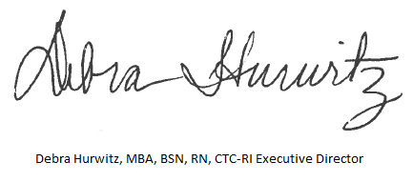

____________________________ ____________________________
Practice Representative Signature CTC-RI Representative Signature

__________________________ ____________________________
Date Date

__________________________
Name

__________________________
Position

__________________________
Practice

