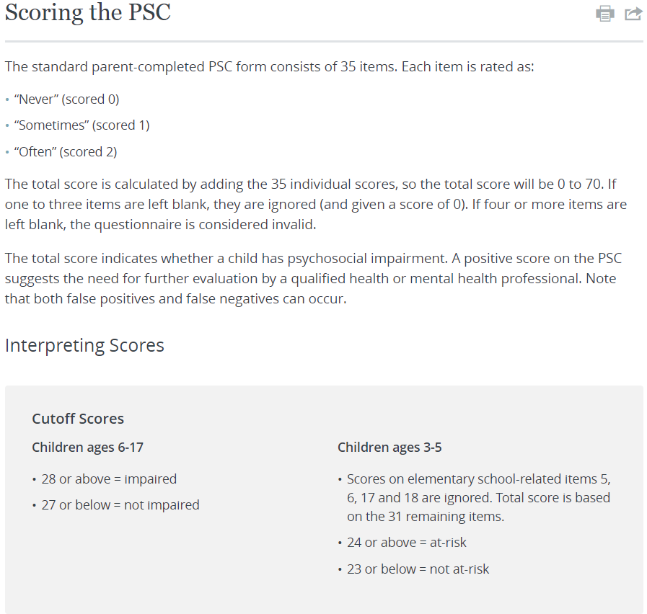

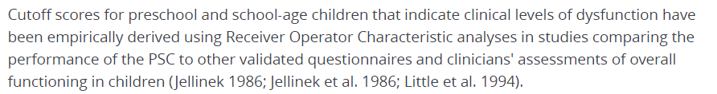

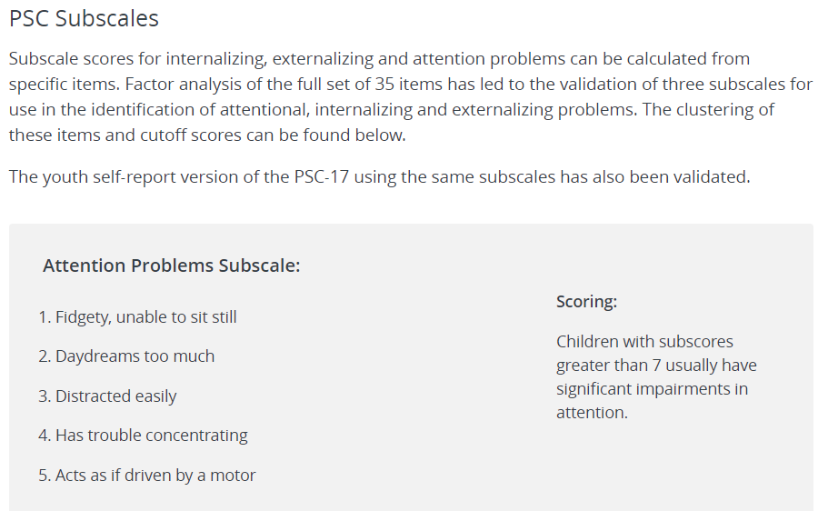

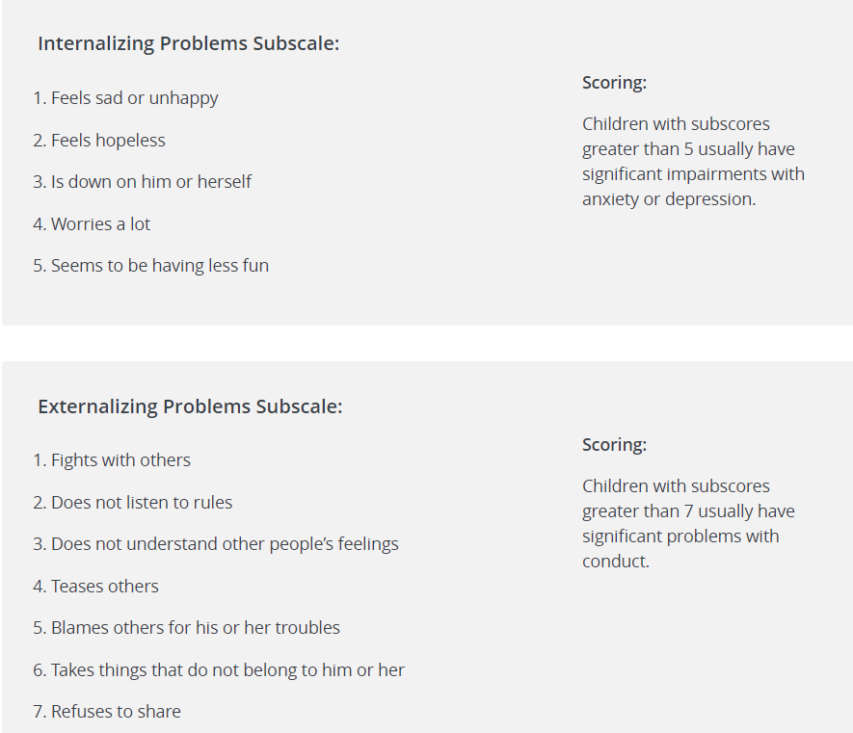

<https://www.massgeneral.org/psychiatry/services/treatmentprograms.aspx?id=2008&display=scoring>