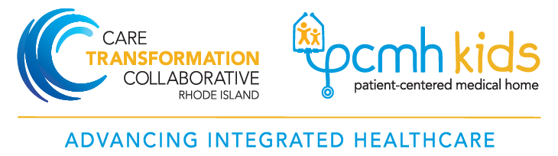

PCMH-Kids Leadership
Pat Flanagan, MD, FAAP  PCMH Kids Co-chair  Phone: 401-248-5507  PFlanagan@Lifespan.org | Beth Lange, MD, FAAP  PCMH Kids Co-chair  Phone: 401-421-6481  ElizLange@cox.net

Care Transformation Collaborative of Rhode Island (CTC – RI)
Management Team

Debra Hurwitz, MBA, BSN, RN  Executive Director  Office: 401-519-3921  Cell: 978-502-9811  DHurwitz@CTC-RI.org | Pano Yeracaris, MD, MPH  Chief Clinical Strategist  Cell: 617-953-5501  Office: 401-519-3924  PYeracaris@ctc-ri.org
Susanne Campbell, RN, MS, PCMH CCE  Senior Project Director  Office: 401 519-3925  Cell: 401 477-0011  Scampbell@ctc-ri.org  Linda Cabral, MM  SBIRT/CHT Project Manager  Office: 401-519-3923  Cell: 617-821-6351  LCabral@ctc-ri.org | Nelly Burdette, PsyD  Senior IBH Program Leader  Office: 401-654-4001  nellyburdette@gmail.com  Candice Brown, BS  Program Coordinator  Office: 401-519-3919  CBrown@ctc-ri.org
Jennifer Capewell, BA Carolyn Karner, MBA
Program Coordinator PCMH-Kids and IBH Project Coordinator
Office: 401-519-3922 Cell: 978-852-2250
JCapewell@ctc-ri.org CKarner@ctc-ri.org

Liz Cantor, PhD
Pediatric IBH Practice Facilitator
Cell: 401-487-1566
Liz.cantor@gmail.com

