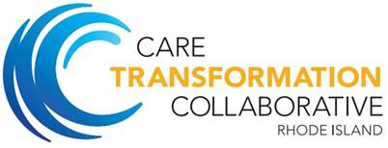

2019 IBH Program

Kick Off Orientation

February 28, 2019 ♦ 7:30-9:00AM

Agenda

|  |  |  |
| --- | --- | --- |
| **Topic** | **Presenter** |  |
| Welcome and Introductions | Deb Hurwitz / Tinisha Richards | 15 minutes |
| CTC IBH Project Overview | Susanne Campbell | 15 minutes |
| Collaborative Agreement Deliverables & Milestones | Susanne Campbell | 15 minutes |
| Overview of Universal Screening & Social Determinants of Health | Nelly Burdette | 30 minutes |
| Next Steps |  | 15 minutes |