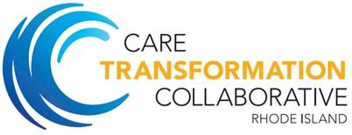

Integrated Behavioral Health

Program

Orientation Binder

Kickoff Event February 28, 2019