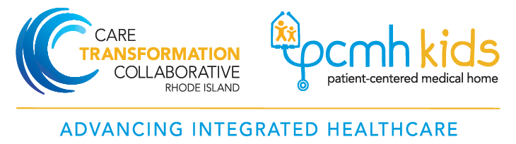

An opportunity for your pediatric primary care / family practice to apply for:

July 2019 CTC / PCMH Kids
Pediatric Integrated Behavioral Health (IBH) Program
WHY APPY?
Up to eight practices will be selected to participate in our IBH pediatric pilot program. Selected practices will be eligible for:
- Infrastructure payment support of $18,000* in the first year (made in two installments);
- Up to $10,000 in incentive payments based on meeting service delivery requirements and screening targets ($5000 year 1; $5000 year 2);
- Monthly on-site consultation with a trained pediatric IBH practice facilitator and quarterly learning sessions with content experts and best practice peer learning opportunities.
*additional infrastructure support may be available for practices that with large panels of patients. Priority is given to practices serving vulnerable populations.

The financial support is provided through a grant from the Rhode Island Foundation Behavioral Health Fund and by Tufts Health Plan. Infrastructure payment is intended to help off-set costs associated with on boarding behavioral health clinician, developing coding and billing mechanisms needed for sustainability and costs associated with non-billable time.

WHAT ARE THE PRACTICE EXPECTATIONS?
The long-term goal is to help your practice address behavioral health needs before families are in crisis. Practices are asked to:
- Select, implement and report out on 3 out of 5 standardized evidence based screening measures choosing from:
1) Depression-PHQ-A (adolescent);
2) Anxiety: GAD-7 (adolescent)
3) Substance use: CRAFFT or CAGE-AID (adolescent)
4) Middle childhood: Pediatric Symptom Checklist
5)Postpartum depression: Edinburgh Postnatal Depression Scale
- Hire and integrate a behavioral health clinician into your practice team
- Use EMR and data tools to enhance workflows, set up registries to track and monitor symptom improvement for children/families with positive screens and meet reporting requirements;
- Meet monthly with on-site integrated behavioral health practice facilitator who will support your practice in achieving your clinical and financial goals;
- Learn from your peers and content experts by participating in quarterly learning collaborative meetings
“This initiative recognizes and capitalizes on the fact that pediatric medical home is the logical place for providing effective integrated mental health promotion, prevention and treatment because the pediatrician is the most likely medical professional that children and adolescents come in contact with during their early and adolescent years and because for children, behavior and development are so much a part of their general health.”
Application deadline:
June 19, 2019
Link to application:
https://www.ctc-ri.org/sites/default/files/uploads/IBH%20application%20RIF%20Pediatric%20Call%20for%20Applications%20v6.docx

For more information:
contact: CTC-RI@ctc-ri.org
- Pat Flanagan, MD, FAAP, PCMH-Kids Co-chair

