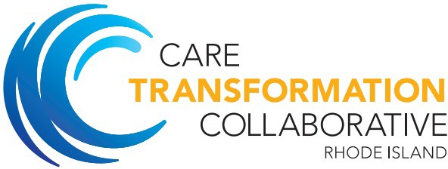 A picture containing clipart

Description generated with very high confidence

**Care Transformation Collaborative of Rhode Island (CTC)** *January 2019 ‘PCMH Kids’ Expansion Opportunity*

**“Call for Applications”**

**WHY JOIN?**

Your practice will receive supplemental payments for three years from health plans in our multi-payer initiative to transform your practice and be recognized as a patient-centered medical home (PCMH).

* Year 1: $3.50 per member, per month for pediatric practices and pediatric patients within family medicine practices
* Years 2 & 3: $3.00 per member, per month with added incentives

**WHY JOIN?**

Your practice will receive supplemental payments for three years from health plans in our multi-payer initiative to transform your practice and be recognized as a patient-centered medical home (PCMH).

* Year 1: $3.50 per member, per month for pediatric practices and pediatric patients within family medicine practices
* Years 2 & 3: $3.00 per member, per month with added incentives

# HOW CAN THIS FINANCIAL SUPPORT HELP?

The added financial incentives available by joining CTC enables your practice to:

* Implement team-based care and support the costs of a Care Coordinator (CC) in your practice. CTC will assist with integration of a CC into your practice;
* Improve satisfaction for yourself, your patients, and staff;
* Use EMR and data tools to enhance workflows, inform care coordination and meet reporting requirements;
* Earn additional incentive payments for achieving quality, customer experience, and utilization thresholds;
* Earn enhanced FFS rates from some local payers with NCQA ‘PCMH Recognition.’

# ADDITIONAL BENEFITS OF JOINING THE COLLABORATIVE:

* Work closely with other pediatricians to increase the quality of pediatric care in Rhode Island.
* Obtain on-site practice facilitation support to achieve NCQA PCMH Recognition, help obtain reports from your EMR, and meet other PCMH achievements.
* Participate in pediatric-specific learning collaboratives featuring national, regional, and local talent.
* Be at the ‘primary care table’ and have an active voice with other practices and health plans, and help keep the unique needs of children in the health care reform conversation.

# HERE TO HELP YOUR PRACTICE THRIVE

**Application deadline: October 31, 2018**

[**Link to Application**](https://www.ctc-ri.org/sites/default/files/uploads/CTC%20RI%202017%20Application%20PCMH%20Kids%201%201%202019%20examsopm%20and%20sc%20and%20deb%20and%20beth.docx)

**Contact information: Carolyn Karner** [**ckarner@ctc-ri.org**](mailto:ckarner@ctc-ri.org)

**Pediatric leadership:**

**Contact:**

**Pano Yeracaris** [**pyeracaris@ctc-ri.org**](mailto:pyeracaris@ctc-ri.org)

There is strong support at the R.I. government-level for primary care transformation. The Office of the Health Insurance Commissioner (OHIC) and Executive Office of Health and Human Services (EOHHS) are co- conveners of the statewide multi-payer transformation initiative directed by CTC. The goal is to transform primary care practices to support improved quality, patient experience, and drive improved healthcare affordability.

Times are changing rapidly. What has worked up until now will not work in the future. Providers may already be receiving reduced payments from some payers for care outside of “transformed” PCMHs. We can help by providing practice facilitation to achieve this transformation. This Collaborative program has been assisting pediatric practices in Rhode Island since 2016 and is here to help your practice succeed.