DELIVERY OF CARE | DEAL FLOW | MIND & BODY | RESEARCH ENGINE | INNOVATION ECOSYSTEM | IN YOUR NEIGHBORHOOD
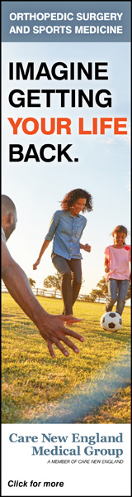
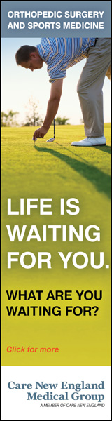
DELIVERY OF CARE

A pediatrician takes on COVID in Central Falls

The untold story of how a dedicated physician, deploying an Abbott testing machine, has attempted to flatten the curve of infection in the state’s smallest city
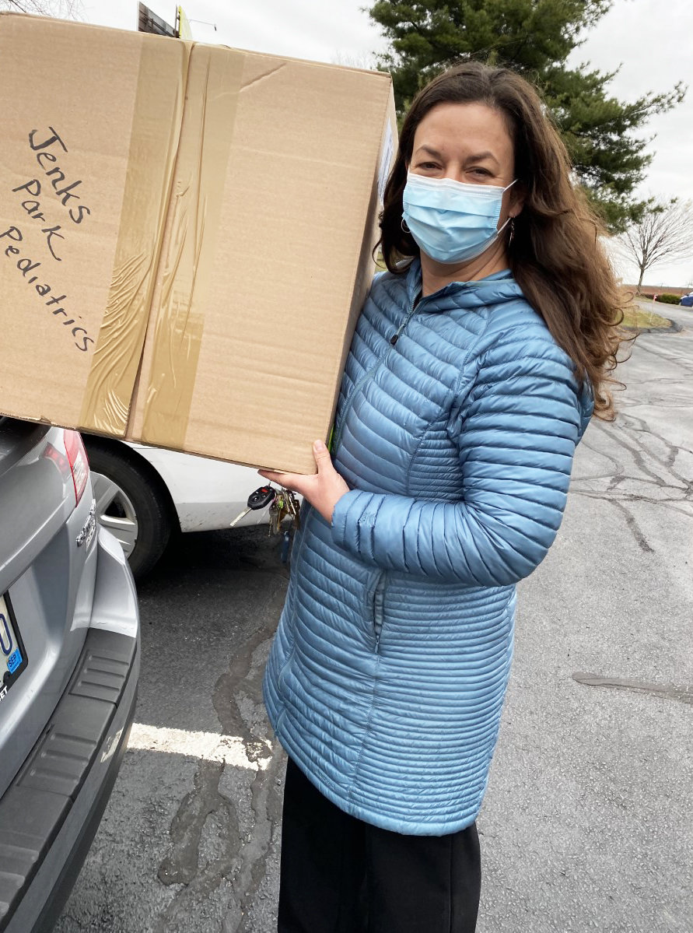
PHOTO COURTESY OF DR. BEATA NELKEN
Dr. Beata Nelken, a pediatrician practicing in Central Falls, collects her Abbott testing device at the R.I. Department of Health on April 30.
By Richard Asinof
Posted 8/10/20
WHY IS THIS STORY IMPORTANT?
Dr. Beata Nelken, a pediatrician, has become the go-to source for testing for the coronavirus for children and families in Central Falls, in her unsung role as a community heroine.
THE QUESTIONS THAT NEED TO BE ASKED
What will it take to have a coordinated state health plan to test children in advance of school openings scheduled for Aug. 31? Would Gov. Raimondo be willing to sit down and talk with Dr. Nelken to find out what is happening on the ground in Central Falls? Is the Rhode Island Foundation willing to make one of its “impact investments” in health care and support the testing infrastructure of Dr. Nelken? How much money is the Governor willing to invest in Health Equity Zones in Rhode Island?
UNDER THE RADAR SCREEN
This week, Gov. Gina Raimondo will conduct a Facebook forum with Dr. Anthony Fauci, who was part of a recent conversation with Dr. Ashish Jha, the incoming dean at the School of Public Health at Brown University on Friday, Aug. 7. As much as conversations with Dr. Fauci bring a national focus to what is happening in Rhode Island, the problem is that the knowledge of what is actually happening on the ground, in communities such as Central Falls and the pediatric practice of Dr. Nelken, is still missing from the conversation.
While it is great to publicize a reporter from The Providence Journal’s experience to be tested so that she can go to her house on the Cape without running afoul of Massachusetts new restrictions that residents from Rhode Island needed to quarantine for 14 days when visiting Massachusetts, the economic situation for many families in Central Falls regarding testing is not a question of access to leisure time on the Cape but how to juggle the realities of work and childcare and housing realities.
As much as the Governor and her team talk about equity and inclusion and racial justice, the problem remains that it is often seems to be more about posturing rather than addressing the nitty-gritty of what is happening on the ground.
CENTRAL FALLS – When Dr. Beata Nelken, a pediatrician, first opened her practice, Jenks Park Pediatrics, six months ago, in February of 2020, on Broad Street, the major thoroughfare in Rhode Island’s smallest city, she knew it was going to be an adventure as a solo practitioner.
But Nelken never imagined that she would find herself in midst of a global pandemic, serving as the principal source of testing for under-served children as the coronavirus swept through the community.
Her goal in setting up shop had been straightforward: “I was answering a need, going to where there was a great need, bringing the greatest skills I had to meet it,” she said. “I wanted to better serve the families of Central Falls, with its large uninsured population, where language is often a barrier to better health outcomes.” Nelken offers free medical care to uninsured children from the community.
Nelken, who speaks Spanish, said that she had been serving the Latinx communities in Rhode Island for 19 years, since 2001, when she began her pediatric residency at Hasbro Children’s Hospital. She most recently worked for Blackstone Valley Community Health Care, including running the Central Falls High School health clinic for a number of years.
In November of 2019, Nelken was recognized by Rhode Island Kids Count as a community hero for her successful efforts to reduce teenage pregnancy in Central Falls by 55 percent over three years. [See link below to ConvergenceRI story, “Why Central Falls is changing the health care landscape.”]
Now, Nelken finds herself as a safe port in the whirlwind of the coronavirus pandemic storm, one of the few pediatricians in Rhode Island with an Abbott testing machine, which she acquired from the R.I. Department of Health on April 30, 2020. She began testing the week of May 4. The testing device was one of four obtained through the Minority Health Office at the state agency. “I called at a time when there was a deliberate effort to expand testing capacity in minority communities,” Nelken said, explaining how she happened to obtain the testing device.
Patients – particularly families with children – have been flocking to Jenks Park Pediatrics in recent weeks, not just from Central Falls but from all across Rhode Island – from Ashaway [near Westerly], Tiverton, Little Compton, North Smithfield, Barrington, Lincoln, Cumberland, North Providence, Warwick and West Warwick, Nelken told ConvergenceRI. “I didn’t recruit; I didn’t advertise,” Nelken said, talking about the power of word of mouth, but many referrals came in from the R.I. Department of Health, when families would call seeking testing for kids.
Word has gotten out, without advertising or promotion. No other pediatric practice open to public testing, it seems, had access to an Abbott testing machine, which provides instant results, even if there may be some problems with accuracy. “No test is perfect,” Nelken said. With the Abbott testing device, she continued, “You can get real time information,” contrasting that with the problems of having to wait 10 days to get a result back for a 30-year-old patient.
While the R.I. Department of Health provides the testing swabs and the tests and some of the Personal Protection Equipment, Nelken said she is responsible for underwriting everything else.
In addition, Nelken had been offering asymptomatic testing for patients, working in partnership with a local community agency during their food bank distribution times.
Six days a week
The demands for testing have been through the roof. During the first six weeks of this summer, Nelken said, she had been averaging nearly 200 visits a week, 10-15 a day for vaccines and well-child visits [spaced 30 minutes apart for proper distancing among families], plus more than 20 visits a day for COVID-19 testing.
Nelken talked about how the spread of the virus had been devastating to the Central Falls community, in part because of the barriers to getting tested – many residents do not have a primary care provider, or did not have access to a car to get to the CVS testing site in Lincoln.
“It was a hopeless feeling, seeing so many community residents, all out of work and all sick, not eligible for any unemployment,” Nelken told ConvergenceRI.
To meet the future increased demand, Nelken said she had placed an order for two new testing machines from BD Veritor, the latest in state-of-the-art testing for coronavirus. The devices can deliver a result in 15 minutes that is purportedly more reliable than the Abbott machine.
Nelken is investing her own financial resources to acquire the new testing devices. “The two machines, plus all the tests to go with it, are expensive – but needed,” she said, “especially since the Dexter Street public testing site has just moved to Pawtucket.”
Testing is free for those without insurance. To further improve care for uninsured children, Nelken said she is in the process of setting up a nonprofit foundation to handle the costs for medication, labs, radiology, and consults for care beyond Jenks Park Pediatrics.
Asking the right questions
When asked what was the most important lessons learned form her experience, Nelken said that people in positions of power needed to be putting more focus on what was happening at the nursery school level in each community, which she described as the true canaries in the coal mine with regard to how the school populations may fare with the upcoming start of classes. Some communities will be placing children and their staff at very high risk by restarting in-person classes. “This is very concerning and ill-advised in some cases,” Nelken said.
The existence of outbreaks at nursery schools and daycare facilities is apparently underreported, with Nelken saying that through her work on testing, she knew of three such outbreaks serving the Central Falls and Pawtucket community, even if they have yet to be publicly acknowledged.
Looking ahead at plans to reopen schools in Rhode Island, Nelken said, “There are a lot of teachers who are the mercy of their schools’ decision.”
Nelken, whose major as an undergrad was African-American Studies, shared how her paternal grandmother and her family were immigrants from Mexico during the revolution. Nelken said she spent three years in her 20’s living and working in Latin America, where she said she got her first experience in dealing with infectious disease outbreaks, serving as a translator and a phlebotomist with the Centers for Disease Control and Prevention, attempting to control an outbreak of Leptospiroris, when people were dying for then-unknown causes.
“It meant hiking door to door in the mountains, visiting the families impacted by death,” Nelken said, “making swabbing noses in the comfort of an air-conditioned office look quite easy.”

Related
Why Central Falls is changing the health care landscape

Comments
NO COMMENTS ON THIS STORY | PLEASE LOG IN TO COMMENT BY CLICKING HERE

