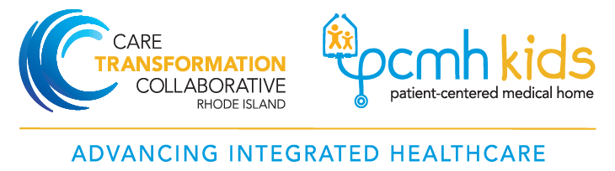

Project Contact Information

Care Transformation Collaborative of Rhode Island (CTC – RI) Management Team | URI, RI DOH and Practice Facilitation Team
Susanne Campbell, RN, MS, PCMH CCE  Senior Project Director  Office: 401-519-3925  Cell: 401 477-0011  Email: SCampbell@ctc-ri.org | Steve Kogut, PhD, MBA, RPh  URI Professor, Program in Pharmacoepidemiology & Pharmacoeconomics  Cell: 401-874-5370  Email:SKogut@uri.edu
Pano Yeracaris, MD, MPH  Chief Clinical Strategist  Office: 401-519-3924  Cell: 617-953-5501  Email: PYeracaris@ctc-ri.org | Debbie Newell, RPh, CDOE, CVDOE  Director, Diabetes Education Partners of Rhode Island and Certified Diabetes Outpatient Educators (CDOE)  Office: 401-223-2982  DeborahNewell@gmail.com
Jazmine Mercado, BS  Program Coordinator  Office: 401-519-3920  Email: JMercado@ctc-ri.org | Megan Fallon-Sheridan, MS, RD  Health Systems Intervention Manager, Division of Community Health and Equity – RI DOH  Office: 401-222-7462  Cell: 401-330-0238  Email: Megan.Fallon@health.ri.gov
Kelley Doherty Sanzen, PharmD, PAHM, CDOE
Practice Facilitator
Cell: 401-480-4758
Email: Kelleyrx@gmail.com

Maureen Maigret RN, BS, MPA
Consumer Consultant
Email: maureenmaigret@gmail.com

