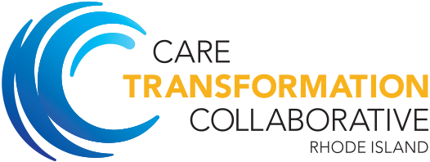

Care Transformations Collaborative of RI

Technical Assistance Offerings
The Targeted Opioid Funding Act will provide Rhode Island with a funding opportunity to better address the needs of Rhode Islanders with substance use disorders. The Care Transformation Collaborative of Rhode Island (CTC-RI) can provide technical assistance to better coordinate care between primary care and Opioid Treatment Centers.
Technical Assistance Offerings:
- Practice facilitation consulting to integrate primary care within substance use treatment centers including needs assessment and planning that is evidence-based;
- Workflow and operational improvements to integrate primary care needs within SUD-MH treatment centers;
- Joint staff training trainings for primary care and opioid treatment staff (front desk/reception, medical assistants, nursing, medical providers, and community health workers) to increase communication and care coordination for patients needing MAT services;
- Strategies to improve referral management between Opioid Treatment Centers and Primary Care;
- Interactive team training on complex topics such as group visits, billing and coding guidance;
- Project management support for Learning Collaborative with speakers and topics central to IBH, SUD-MH issues.
- Implementation of SBIRT screening in various clinical and community based settings
- Implementation of Community Health Teams for high risk patients
For more information contact: Debra Hurwitz CTC Executive Director dhurwitz@ctc-ri.org; 401-519-3921

