TABLE OF CONTENTS

Revised June 30, 2022 - Previous Version August 14,2020

Active Patient(s) All Scopes of Work_________________________________________ 2
Scope of Work Specific Screenshots of form used to submit Active Patient(s) 3
Prediabetes/Diabetes control and prevention
Prediabetes draft measure 4 diabetes mellitus: HbA1c in Poor Control (>9 or none) 5
screenshot of form used to submit diabetes in poor control 6
cardiovascular disease management and prevention
hypertension: blood pressure in control 7
screenshot of form used to submit Hypertension: Blood Pressure in Control 8
statin therapy for the prevention and treatment of cardiovascular disease 9
screenshot of form used to submit statin therapy of prevention and treatment of cvd 10
elevated blood pressure without hypertension diagnosis 11
screenshot of form used to submit elevated blood pressure without htn diagnosis 12

seLf measurement of blood pressURE
patient submission of blood pressure readings 13
screenshot of form used to enter patient submission of blood pressure readings 14

CCE Measure Specifications for all SOW, effective June 30,2022
 | Active Patient(s)
Measure Description | Patients 18-85 years of age who have been seen by a primary care clinician of the practice anytime within the last 12 months.
 | Definition of primary care clinician includes the following: MD/DO, Physician’s Assistant (PA), and Certified Nurse Practitioner (CNP).
Acceptable Exclusions | Patients who have left the practice, as determined by one or more of the following:  - Patient has asked for records to be transferred or otherwise indicated that they are leaving the practice  - Patient has passed away  - Patient cannot be reached on 3 consecutive occasions via phone or emergency contact person  - Patient has been discharged according to a practice’s discharge policy

Screenshots of Form used to submit Measure Data 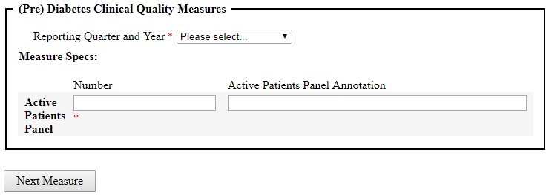

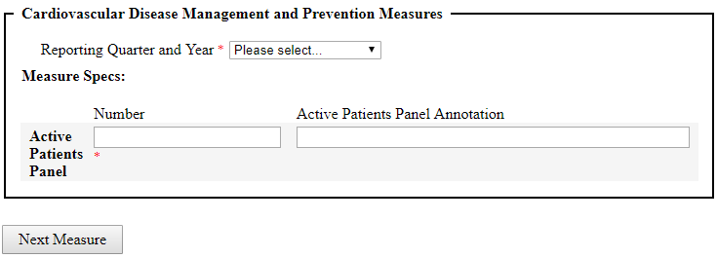

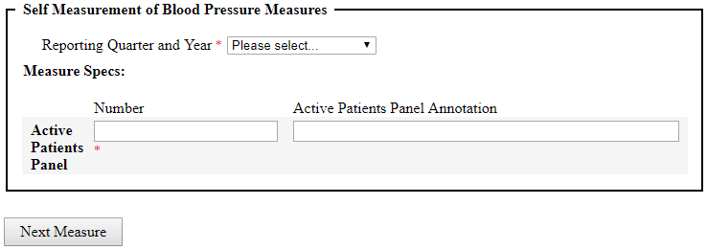

CCE Measure Specifications Prediabetes/Diabetes SOW, effective June 30,2022

Prediabetes Measure
Please refer to Scope of Work Document for further suggestions.
Measure Description | Percentage of patients aged 21 years and older who have risk factors for diabetes, were seen for at least two office visits or one preventive visit in the 12-month measurement period and were screened or have documented previous results for abnormal blood glucose at least once in the last 3 years (R73.03)
Measurement Period | 12 months
Numerator | Patients who were screened for abnormal blood glucose at least once in the last 3 years
Denominator | All patients aged 21 years and older who have risk factors* for diabetes seen for at least 2 office visits or one preventive visit during the 12-month measurement period. Risk factors for diabetes include: Adults who are overweight or obese (BMI ≥25 kg/m2 or ≥23 kg/m2 in Asian Americans) who have one or more of the following: First-degree relative with diabetes •High-risk race/ethnicity (e.g., African American, Latino, Native American, Asian American, Pacific Islander)  •History of CVD  •Blood pressure ≥140/90 mmHg or on therapy for hypertension  •HDL cholesterol level <35 mg/dL (0.90 mmol/L) and/or triglyceride level >250  mg/dL (2.82 mmol/L)or on therapy for hypercholesterolemia  •Women with polycystic ovary syndrome  •Physical inactivity  •Other clinical conditions associated with insulin resistance (e.g., severe obesity,  acanthosis nigricans)  •History of gestational diabetes mellitus
Denominator Exclusions | Exclude patients who are pregnant. Exclude patients who have any existing diagnosis 2 diabetes (Type 1, Type 2, latent autoimmune diabetes of adults [LADA], monogenic diabetes [MODY]).  Exclude patients in palliative care/hospice
Measure source | CDC
Additional Information | CDC: https://www.cdc.gov/diabetes/prevention/lifestyle-program/deliverers/index.html  AMA: https://www.stepsforward.org/modules/prevent-type-2-diabetes

CMS122v10 | Diabetes Mellitus: HbA1c in Poor Control (>9 or NONE)
Measure Description | Percentage of patients 18-75 years of age with diabetes who had hemoglobin A1c > 9.0% or missing during the measurement period
Measurement Period | 12 months
Numerator | Patients whose most recent HbA1c level (performed during the measurement period) is >9.0% or is missing or was not performed during the measurement period.
Denominator | Patients 18-75 years of age with diabetes with a visit during the measurement period
Denominator Exclusions | Exclude patients who are in hospice care for any part of the measurement period.  Exclude patients 66 and older who are living long term in an institution for more than 90 consecutive days during the measurement period.  Exclude patients 66 and older with an indication of frailty for any part of the measurement period who meet any of the following criteria:  - Advanced illness with two outpatient encounters during the measurement period or the year prior  - OR advanced illness with one inpatient encounter during the measurement period or the year prior  - OR taking dementia medications during the measurement period or the year prior.  Exclude patients receiving palliative care during the measurement period.
Measure source | https://ecqi.healthit.gov/ecqm/ec/2022/cms122v10
Additional Information | http://clinical.diabetesjournals.org/content/36/1/14  CMS122v10-eCQMFlow.pdf
Goal | Demonstrate that the percentage of patients with HgbA1c in Poor Control (HgbA1c is >9% or missing) is at or below the goal of 25%
Changes from previous version | N/A

Screenshot of Form used to submit Measure Data 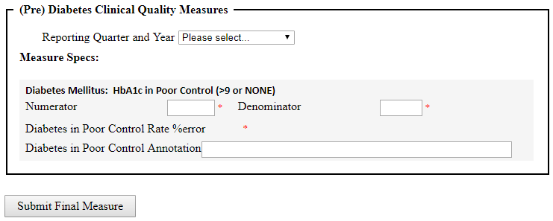

CCE Measure Specifications for Cardiovascular Disease SOW, effective June 30, 2022
CMS165v10 | Hypertension: Blood Pressure in Control
Measure Description | Patients 18-85 years of age who had a diagnosis of essential hypertension starting before and continuing into, or starting during the first six months of the measurement period, and whose most recent blood pressure was adequately controlled (<140/90mmHg) during the measurement period
Measurement Period | 12 months
Numerator | Patients whose blood pressure at the most recent visit is adequately controlled (systolic blood pressure < 140 mmHg and diastolic blood pressure < 90 mmHg) during the measurement period
Denominator | Patients 18-85 years of age who had a visit and diagnosis of essential hypertension starting before and continuing into or starting during the first six months of the measurement period.
Denominator Exclusions | Patients with evidence of end stage renal disease (ESRD), dialysis or renal transplant before or during the measurement period. Also exclude patients with a diagnosis of pregnancy, are in hospice during the measurement period.  Exclude patients 66 and older who are living long term in an institution for more than 90 consecutive days during the measurement period or with an indication of frailty for any part of the measurement period who meet any of the following criteria:  - Advanced illness with two outpatient encounters during the measurement period or the year prior OR advanced illness with one inpatient encounter during  - OR taking dementia medications  Exclude patients 81 and older with an indication of frailty  Exclude patients receiving palliative care
Measure source | https://ecqi.healthit.gov/ecqm/ec/2022/cms165v10
Additional Information | https://www.cdc.gov/bloodpressure/about.htm  CMS165v10-eCQMFlow.pdf  In reference to the numerator element, only blood pressure readings performed by a clinician, or a remote monitoring device are acceptable for numerator compliance with this measure. This includes blood pressures taken in person by a clinician and blood pressures measured remotely by electronic monitoring devices capable of transmitting the blood pressure data to the clinician. Blood pressure readings taken by a remote monitoring device and conveyed by the patient to the clinician are also acceptable. It is the clinician’s responsibility and discretion to confirm the remote monitoring device used to obtain the blood pressure is considered acceptable and reliable and whether the blood pressure reading is considered accurate before documenting it in the patient’s medical record.
Goal | Demonstrate that the percentage of patients with HTN in control is at or above the goal of 75%
Summary of changes. Please refer to previous version for specific details | Measure description has changed to starting before and continuing into or starting during the first six months. Exclude criteria (age specific) for patients with frailty, advanced illness, taking dementia medications, receiving palliative care.

Screenshot of Form used to submit Measure Data 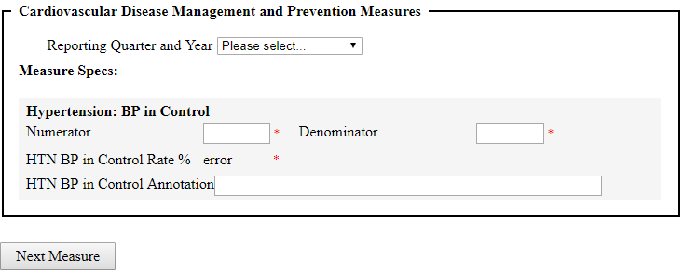

CCE Measure Specifications for Cardiovascular Disease SOW, effective June 30, 2022
CMS347v5 | Statin Therapy for the Prevention and Treatment of Cardiovascular Disease
Measure Description | Percentage of the following patients - all considered at high risk of cardiovascular events - who were prescribed or were on statin therapy during the measurement period:  *All patients who were previously diagnosed with or currently have an active diagnosis of clinical atherosclerotic cardiovascular disease (ASCVD) including an ASCVD procedure; OR  *Patients aged >= 20 years who have ever had low-density lipoprotein cholesterol (LDL-C) level >= 190 mg/dL or were previously diagnosed with or currently have an active diagnosis of familial hypercholesterolemia; OR  *Patients aged 40-75 years with a diagnosis of diabetes
Measurement Period | 12 months
Numerator | Patients who are actively using or who receive an order (prescription) for statin therapy at any time during the measurement period
Denominator | Population 1: All patients who were previously diagnosed with or currently have an active diagnosis of clinical ASCVD, including an ASCVD procedure  Population 2: Patients aged >= 20 years at the beginning of the measurement period who have ever had a laboratory result of LDL-C >=190 mg/dL or were previously diagnosed with or currently have an active diagnosis of familial hypercholesterolemia  Population 3: Patients aged 40 to 75 years at the beginning of the measurement period with Type 1 or Type 2 diabetes
Denominator Exclusions | Patients who have a diagnosis of pregnancy, at any time during the measurement period.  Patients who are breastfeeding, at any time during the measurement period.  Patients who have a diagnosis of rhabdomyolysis (breakdown of muscle tissue that leads to the release of muscle fiber contents into the blood. These substances are harmful to the kidney and often cause kidney damage.)
Measure source | https://ecqi.healthit.gov/ecqm/ec/2022/cms347v5
Additional Information | Https://www.heart.org/-/media/files/health-topics/cholesterol/chlstrmngmntgd_181110.pdf  CMS347v5-eCQMFlow.pdf
Summary of changes Please refer to previous version for specific details. | Measure description includes all patients and including an ASCVD procedure. Age has changed to 20 and having an LDL level >= 190 mg/dL. Pure hypercholesterolemia has been removed and patients ages 40-75 have to have just a diagnosis of diabetes without the fasting LDL.

Screenshot of Form used to submit Measure Data
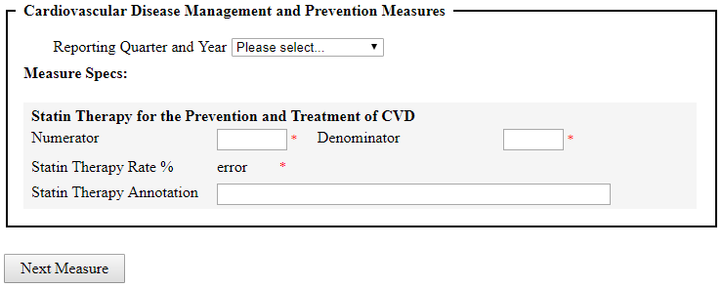

CCE Measure Specifications for Cardiovascular Disease SOW, effective June 30,2022
 | Elevated Blood Pressure without Hypertension Diagnosis:
Hiding in Plain Sight, Step 1
Measure Description | Number of patients who do not have a diagnosis of hypertension with two or more blood pressure readings > 140 mmHg SBP and/or >90 mmHg DBP.
Numerator | Patients who have systolic blood pressure >140 mmHg and/or diastolic blood pressure >90 mmHg at two separate medical visits, including the most recent visit, during the past 12 months.
Denominator | All patients aged 18-85 who do not have a hypertension diagnosis and had a medical visit in the last 12 months.
Exclusions | Pregnancy, end-stage renal disease (ESRD)
Measure source | EHR
Notes | In addition to the data report, these specifications can be used to develop a list of patients who may have hypertension and be "Hiding In Plain Sight" (HIPS). Practice should develop a process to review this cohort of patients and follow up as necessary to determine if they have hypertension.
Additional Information | Hypertension Control Change Package for Clinicians. A Million Hearts® Action Guide. Atlanta, Ga: Centers for Disease Control and Prevention, US Department of Health and Human Services. 2015.
 | Million Hearts: Leveraging Health Information Technology (HIT), Quality Improvement (QI), and Primary Care Teams to Identify Hypertensive Patients Hiding in Plain Sight (HIPS). NACHC Million Hearts HIPS Change Package. National Association of Community Health Centers. 2015
Changes from previous version | NA

Screenshot of Form used to submit Measure Data 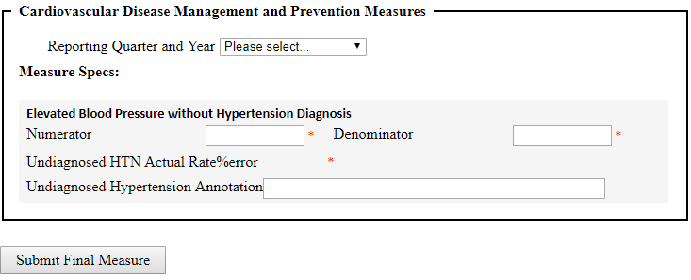

CCE Measure Specifications for SMBP SOW, effective June 30,2022
 | SMBP: Patient Submission of Blood Pressure Readings
Measure Description | Percent of patients with a diagnosis of hypertension who were advised by their provider to Self-Measure Blood Pressure (SMBP), and who have submitted their blood pressure readings to their provider at least once during the measurement period
Numerator | Patients in the denominator who communicate blood pressure reading(s) to their providers’ office at least once during the past 12 months.
Denominator | Active patients* 18 years of age or older with hypertension (or suspected hypertension) who were seen during the last 12 months and who have a documented plan to self-measure their blood pressure.
 | ICD-10 codes: I10
Denominator Exclusions | Patients less than 18 years of age
Measure source | EHR
Additional Information | Million Hearts® Self-Measured Blood Pressure Monitoring, Action Steps for Clinicians. A Million Hearts® Action Guide. Atlanta, Ga: Centers for Disease Control and Prevention, US Department of Health and Human Services. 2014.
Changes from previous version | NA

Screenshot of Form used to submit Measure Data 