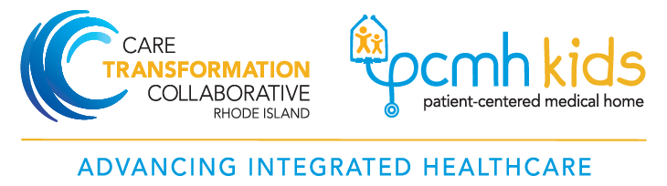
CTC-RI Care Management Service Delivery Requirement Opportunities for Care Coordinator Training Programs
PCMH Kids practices that entered into the CTC-RI common contract have a Care Management Service Delivery Requirement to complete a standardized learning program as defined by CTC.

CTC is providing PCMH Kids practices with two different options to meet the standardized learning program requirement:

Option 1: (xGLearn Core Curriculum Participative Agreement): OR
Option 2: (ECHO Pediatric Complex Management Program registration and MOA):
Option 1: xGLearn Core Curriculum Standardized Learning Program
The Care Transformation Collaborative of Rhode Island (CTC-RI) was awarded a $148,000 grant from UnitedHealthcare to purchase access to core curriculum licenses for the xGLearn online learning modules. PCMH Kids practices and primary care practices that are part of a system of care may apply.

CTC Rhode Island has contracted with xG Health Solutions to provide a blended educational learning experience for Care Managers and Care Coordinators. Faculty members, selected by CTC-RI and trained by xG Health Solutions, will facilitate the NCM/CC’s learning experiences. Additionally, nurses will have the opportunity to earn RN CEU’s and CCM credits that can be applied for Case Management certification. These credits can assist a learner with obtaining care management certification, but the program is not intended to be a care management certification course.
Core Curriculum Training includes:
- Web-based interactive modules
- Weekly NCM/CC faculty-facilitated telephonic collaboration sessions with a cohort of other NCM/CC’s
- WebEx GoToMeetings and a mandatory case study capstone presentation facilitated by each learner

Time Commitment:
All learners will have access to the complete curriculum. The curriculum training has been tailored based on years of experience and if in a NCM or Care Coordinator position
- New NCM: Recommended that new NCM/CC’s with less than 1-year experience participate in all 18 modules (time: 43 hours).
- Experienced NCM: Recommended to complete 8 modules (27 hours); will have access to all 18 modules.
- Pediatric care coordinators: Recommended to complete 14 modules (27 hours); will have access to all 18 modules.
GLearn Program Description can be found here . Practices will receive more information on the xGLearn Program closer to the “launch” date.
Option 2: ECHO Complex Integrated Pediatrics Care Management Option
Weitzman ECHO Complex Integrated Pediatrics connects primary care medical and behavioral health providers nationally with a multidisciplinary team of specialists in complex pediatric care. The Complex Integrated Pediatrics clinic uses twice-monthly videoconferencing sessions to explore a variety of topics designed to improve the quality of care and clinical outcomes for underserved children and adolescents. Specialists from Community Health Center, Inc., Connecticut Children’s Specialist Group, New England Regional Genetics Network, and the University of Connecticut present on key issues and provide recommendations on challenging cases posed by participants. The clinic is designed to emphasize the integration and collaboration between medical and behavioral health providers, reducing variations in care. Participants develop new clinical competencies and confidence with complex pediatric cases. The nine-month program addresses topics such as asthma management and treatment; obesity; diabetes; suicide/self-harm; autism; and cardiology.
This program aims to:
- Build learning communities,
- Reduce provider isolation in rural settings,
- Improve health care outcomes, and
- Improve access to specialty care.
The Complex Integrated Pediatrics ECHO Sessions are held on the 1st and 3rd Monday of every month from 2:00-3:30pm. The program is available at no cost.

PCMH Kids NCM/CC’s interested in this option will be asked to register for the program and submit a completed memorandum of agreement to CTC-RI (Ckarner@ctc-ri.org ) based on service delivery requirement timeline.

Registration information can be found here: https://www.weitzmaninstitute.org/complex-integrated-pediatrics/

Memorandum of Agreement
For more information about the ECHO Pediatric Complex Care Program and to obtain the Memorandum of Areement contact: Agi Erickson, Director of Project ECHO (EricksA@chc1.com), (860) 347-6971 ext. 3741.
For more information about the CTC standardized learning curriculum requirements: contact Susanne Campbell, Senior Project Director (Scampbell@ctc-ri.org ).

