Instructions to Enter Clinical Quality Measures
Step 1: Use dropdown for Practice Name to select your Practice
Step 2: Enter your First Name, Last Name and Email Address
Step 3: Use dropdown to select appropriate Reporting Year, and Reporting Quarter
Step 4: Enter Numerator and Denominator for each Measure, respectively – if you need to enter 0, please place the number 0 in the Numerator field, and 1 in the Denominator field, and add an annotation, if applicable.
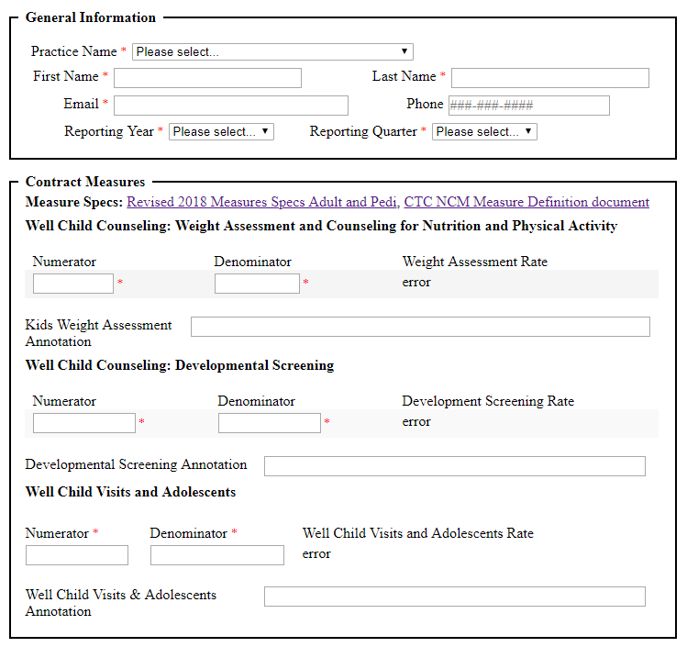
Click “Submit” and you are done!

