Kids' Link RI™

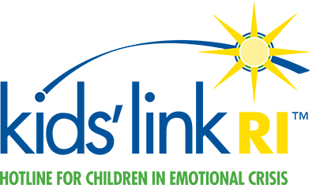
Kids’ Link RI™ is a hotline for children in emotional crisis. A program offered in collaboration with Gateway Healthcare, Lifespan, Hasbro Children's Hospital and Bradley Hospital, Kids’ Link RI is available 24 hours a day, seven days a week for children suffering from behavioral problems or psychiatric illness.​

Call 1-855-543-5465 if your child is:
- Feeling excessive anger or sadness
- Lashing out at siblings, friends, and adults
- Having behavior problems at school
- Having severe worries
- Hurting himself/herself or others
The free hotline, 1-855-543-5465, connects parents and caregivers to children’s services in Rhode Island, and helps parents determine the best place to go for treatment and counseling.
With this confidential hotline, parents and caregivers can dial a toll-free number, to speak to an experienced clinician.

Locations
Bradley Hospital Crisis Clinic
1011 Veterans Memorial Parkway
East Providence, RI 02915
1-855-543-5465

Related Services
Access Center at Bradley HospitalBradley Outpatient ServicesChild Psychiatric Urgent ServicesEmergency Services at The Miriam HospitalEmergency Services at Rhode Island HospitalChild Psychiatry

