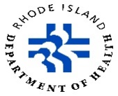
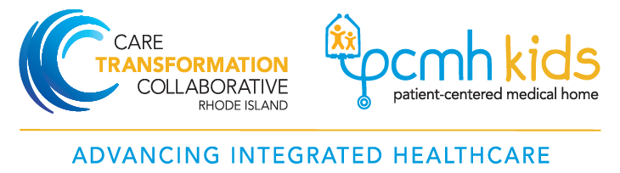

RI MomsPRN - Cohort 3 Practices

Blackstone Valley Community Health Care
Pawtucket RI 02860
RI Home Birth & Hope Family Health
Hope RI 02831
Tri-County Community Action Agency
Johnston RI 02919
VICTA
Providence RI 02907
WIH Maternal Fetal Medicine
Providence RI 02906
Comprehensive Community Action Program
Cranston RI 02920
Direct Doctors
East Greenwich RI 02818
Full Circle Health
Woonsocket RI 02895
RI Women’s Health and Midwifery
Woonsocket RI 02895

