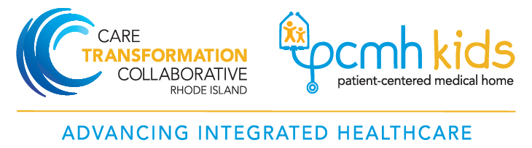

Rhode Island Department of Health  Leadership Team | Care Transformation Collaborative of Rhode Island (CTC – RI)  Management and Practice Facilitation Team
Jayne Daylor, RN, MS  Quality Improvement Consultant  Cell: 401-529-7678  Jayne.Daylor@health.ri.gov | Susanne Campbell, RN, MS, PCMH CCE  Senior Project Director  Office: 401 519-3925  Cell: 401 477-0011  SCampbell@ctc-ri.org
Megan Fallon-Sheridan, MS, RD  Program Administrator  Office: 401-222-3667  Megan.Fallon@health.ri.gov | Carolyn Karner, MBA  Data Manager and Project Coordinator  Office: 978-852-2250  CKarner@ctc-ri.org
Breanne DeWolf, MA, CHW  Health Systems Transformation Manager  Office: 401-222-7742  Breanne.DeWolf@health.ri.gov | Susan Dettling, BS, PCMH CCE  Practice Facilitator  Cell: 401-465-9203  SDettling@ctc-ri.org
Kelsea Tucker, MS  Community Health Network Manager  Office: 401-222-7635  Kelsea.Tucker@health.ri.gov | Suzanne Herzberg, PhD, MS, OTR/L  Practice Facilitator  Cell: 401-263-6023  Suzanne_Herzberg@brown.edu
Edyth Dwyer, MPA, MPH
Project Coordinator
Office: 401-519-3919
EDwyer@ctc-ri.org

Rhode Island Health Center Association | Advocates for Human Potential, Inc.
Der Kue, PMP  Clinical Support Manager  Office: 401-709-8973  DKue@rihca.org | Adrian Bishop, BS  eHealth and Organizational Development Director  ABishop@ahpnet.com

