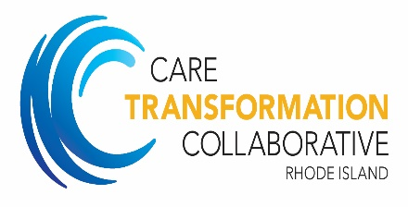

NCQA Resources

Patient Centered Medical Home Recognition:

CTC can provide practices with a discount code for NCQA recognition which provides a 20% reduction in the cost of your application.

Other resources:

BizMed Solutions: Provides free PCMH management software and consultation for NCQA Recognition www.bizmedsolutions.com
https://www.bizmedtoolbox.com/DownloadFileHandler.ashx?file=https://www.bizmedtoolbox.com:443/Resources/Tools/20171016081342489AC-Appointments%20Access%20Toolkit.xlsx

https://www.bizmedtoolbox.com/Webforms/Home.aspx

NCQA website: www.ncqa.org Please follow the link to PCMH

