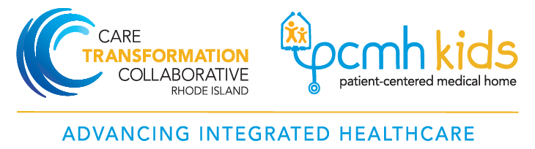

Sample: Nurse Care Manager Roles and Responsibilities
Nurse Care Manager Job Description

Position Summary: A registered nurse, working in conjunction with a care team, to identify and proactively manage the care needs of high-risk patients and other patients identified by the practice as needing targeted support within the primary care practice setting. The Nurse Care Manager is responsible for providing comprehensive screenings, assessment, and care coordination services with particular attention to transitions of care, disease education and self-management support. The Nurse Care Manager will be integrated into the patient centered medical home (PCMH), and will work in partnership with the health care team to promote the triple aim of reduced costs, improved health outcomes and increased patient satisfaction. The Nurse Care Manager will have frequent contact with primary care providers and other medical home team members and will actively participate in interdisciplinary patient-centered team meetings. The Nurse Care Manager will work with patients’ families and other caregivers as warranted by patient needs. Work will be documented and integrated into the office’s electronic medical record (EMR) system.

Essential Job Duties and Responsibilities:

- Provides care management services under the direction of the practice manager or provider.

- Works with the care team to identify and reach out to patients with a high risk of adverse health outcomes as defined by CSI or identified by payers and care providers.

- Completes initial patient assessment, including a comprehensive medical, psychosocial and functional evaluation of the patient, in the office or home setting as needed; reviews assessment with provider and clinical team members.

- Uses behavior change techniques such as motivational interviewing to establish therapeutic relationships with patients enabling effective intervention and support.

- Supports the patient in identification of actionable goals to optimize health outcomes;

- Develops a plan of care with the patient that promotes improved health care outcomes and quality of life informed by patient’s goals, strengths and barriers;

- Implements the patient approved plan of care in collaboration with the patient through the practice's care team, community resources and home based visits and telephonic support;

- Provides other aspects of comprehensive care management including self-management support and health promotion,

- Advocates for patients to ensure access and timely service delivery across the continuum of care and community resources, including behavioral health, community based organizations and social supports to address barriers to optimum patient health;

- Supports the team with reviewing and addressing clinical quality measures, emergency room and hospital utilization, access to care, communication with patients and patient satisfaction

- Provides or provides access to culturally and linguistically appropriate services as needed.

- Supports the team in providing access to age-appropriate patient services as needed.

- Works with providers to facilitate effective transitions to/from specialists, hospitals and other care providers through the timely communication of necessary information for patient care and discharge planning.

- Conducts medication reconciliation as appropriate and communicates any need for adjustment to care team and providers. Provides support to patients to enhance medication adherence. Documents any changes in patient’s EMR.

- Works with caregivers as appropriate to clarify the patient's needs, assess caregiver burden and provide support to family and caregivers.

- Meets practice policies and procedures related to documentation utilizing software tools that track care management activities and their effectiveness.

- Generates reports on service volume and distribution of patients by plans and types of services provided.

- Handles confidential information in accordance with HIPAA as well as state and federal privacy and confidentiality rules.

- Works with interdisciplinary team to plan and monitor quality improvement initiatives

- Communicates with care management staff from health care plans as appropriate

General Requirements:

- Participates as a member of the care team.

- Performs work consistent with evidence based treatment guidelines, office policies and procedures and NCQA PCMH Recognition Standards.

- Shares best practices among all team members, serves as a medical home advocate, mentors and leads by example to support a positive work environment and encourages other staff to do the same.

- Participates in meetings and huddles as appropriate.

- Participates in regular CTC NCM meetings for peer support and education

- Conducts pre-visit planning and post-visit follow-up for the care managed patients.

- Provides feedback to providers regarding patient progress and barriers encountered.

- Prepares for and participates in case review meetings to share discoveries, concerns and collaborate in the development of plans of care.

Position Qualifications:

- RN from an accredited program: licensed in State of RI.

- Excellent communication skills and ability to form collaborative partnerships across all service settings.

- Knowledge of community resources

- Experience of 3-5 years in community health setting, public health, chronic disease management, community nursing, or case management preferred.

- Certified as diabetic educator or in another chronic care area, preferably within 12 months of employment.

- Additional care management training and certification is strongly encouraged.

